Employee Referral Program Guide
HR Knowledge Hub | Recruiting and Onboarding | Owner: Priya Natarajan | Last updated: October 30, 2026

Section 1: Executive Summary & Scope
Explains referral bonus tiers, eligible roles, and the payout schedule tied to new hire retention milestones. Section 1 (Executive Summary & Scope) applies to Recruiting and Onboarding within HR Knowledge Hub and is maintained by Priya Natarajan. Defines the operational charter, scope boundaries, and executive accountability.
Operational requirement 1.1: Standard roles pay a $2,000 referral bonus; hard-to-fill engineering roles pay $4,000. Secondary control 1.2: Half of the bonus is paid at hire and half after the referred employee's 90-day mark.
- Standard roles pay a $2,000 referral bonus; hard-to-fill engineering roles pay $4,000.
- Half of the bonus is paid at hire and half after the referred employee's 90-day mark.
- Section 1 review cadence is tracked by Priya Natarajan under Recruiting and Onboarding governance.
Control Area | Owner | Target SLA | Verification Status
Recruiting and Onboarding | Priya Natarajan | 5 business days | Verified
Employee Referral Program Gu Gate 1 | Priya Natarajan | 3 business days | Active
Employee Referral Program Gu Gate 2 | Priya Natarajan | 10 business days | Monitored
Page 1 of 7 | HR Knowledge Hub | Recruiting and Onboarding | SharePoint Online

Section 2: Architecture & Process Flow
Explains referral bonus tiers, eligible roles, and the payout schedule tied to new hire retention milestones. Section 2 (Architecture & Process Flow) applies to Recruiting and Onboarding within HR Knowledge Hub and is maintained by Priya Natarajan. Maps end-to-end process stages, handoff gates, and system-of-record integrations.
Operational requirement 2.1: Half of the bonus is paid at hire and half after the referred employee's 90-day mark. Secondary control 2.2: Referrals are ineligible for roles the referrer's own manager is hiring for.
- Half of the bonus is paid at hire and half after the referred employee's 90-day mark.
- Referrals are ineligible for roles the referrer's own manager is hiring for.
- Section 2 review cadence is tracked by Priya Natarajan under Recruiting and Onboarding governance.
Control Area | Owner | Target SLA | Verification Status
Recruiting and Onboarding | Priya Natarajan | 5 business days | Verified
Employee Referral Program Gu Gate 1 | Priya Natarajan | 3 business days | Active
Employee Referral Program Gu Gate 2 | Priya Natarajan | 10 business days | Monitored
Sec-2 | Priya Natarajan | 3 business days | Stage 2 Verified
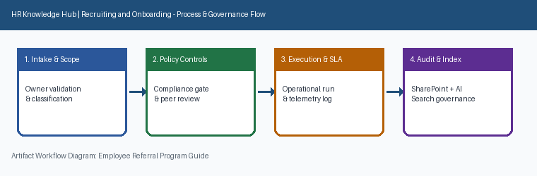
Page 2 of 7 | HR Knowledge Hub | Recruiting and Onboarding | SharePoint Online

Section 3: Governance Standards & Controls
Explains referral bonus tiers, eligible roles, and the payout schedule tied to new hire retention milestones. Section 3 (Governance Standards & Controls) applies to Recruiting and Onboarding within HR Knowledge Hub and is maintained by Priya Natarajan. Establishes mandatory compliance controls, approval thresholds, and audit evidence.
Operational requirement 3.1: Referrals are ineligible for roles the referrer's own manager is hiring for. Secondary control 3.2: Program performance is reviewed quarterly against overall sourcing mix.
- Referrals are ineligible for roles the referrer's own manager is hiring for.
- Program performance is reviewed quarterly against overall sourcing mix.
- Section 3 review cadence is tracked by Priya Natarajan under Recruiting and Onboarding governance.
Control Area | Owner | Target SLA | Verification Status
Recruiting and Onboarding | Priya Natarajan | 5 business days | Verified
Employee Referral Program Gu Gate 1 | Priya Natarajan | 3 business days | Active
Employee Referral Program Gu Gate 2 | Priya Natarajan | 10 business days | Monitored
Sec-3 | Priya Natarajan | 10 business days | Stage 3 Verified
Page 3 of 7 | HR Knowledge Hub | Recruiting and Onboarding | SharePoint Online

Section 4: Operational KPIs & Benchmarks
Explains referral bonus tiers, eligible roles, and the payout schedule tied to new hire retention milestones. Section 4 (Operational KPIs & Benchmarks) applies to Recruiting and Onboarding within HR Knowledge Hub and is maintained by Priya Natarajan. Tracks baseline performance, target SLAs, and quarterly benchmark progression.
Operational requirement 4.1: Program performance is reviewed quarterly against overall sourcing mix. Secondary control 4.2: Standard roles pay a $2,000 referral bonus; hard-to-fill engineering roles pay $4,000.
- Program performance is reviewed quarterly against overall sourcing mix.
- Standard roles pay a $2,000 referral bonus; hard-to-fill engineering roles pay $4,000.
- Section 4 review cadence is tracked by Priya Natarajan under Recruiting and Onboarding governance.
Control Area | Owner | Target SLA | Verification Status
Recruiting and Onboarding | Priya Natarajan | 5 business days | Verified
Employee Referral Program Gu Gate 1 | Priya Natarajan | 3 business days | Active
Employee Referral Program Gu Gate 2 | Priya Natarajan | 10 business days | Monitored
Sec-4 | Priya Natarajan | 5 business days | Stage 4 Verified
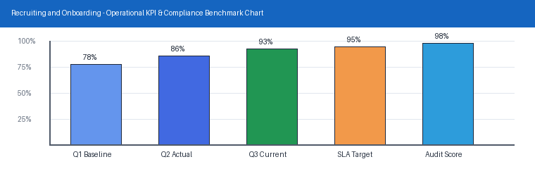
Page 4 of 7 | HR Knowledge Hub | Recruiting and Onboarding | SharePoint Online

Section 5: Roles, Responsibilities & RACI
Explains referral bonus tiers, eligible roles, and the payout schedule tied to new hire retention milestones. Section 5 (Roles, Responsibilities & RACI) applies to Recruiting and Onboarding within HR Knowledge Hub and is maintained by Priya Natarajan. Clarifies ownership across accountable executives, operational leads, and reviewers.
Operational requirement 5.1: Standard roles pay a $2,000 referral bonus; hard-to-fill engineering roles pay $4,000. Secondary control 5.2: Half of the bonus is paid at hire and half after the referred employee's 90-day mark.
- Standard roles pay a $2,000 referral bonus; hard-to-fill engineering roles pay $4,000.
- Half of the bonus is paid at hire and half after the referred employee's 90-day mark.
- Section 5 review cadence is tracked by Priya Natarajan under Recruiting and Onboarding governance.
Control Area | Owner | Target SLA | Verification Status
Recruiting and Onboarding | Priya Natarajan | 5 business days | Verified
Employee Referral Program Gu Gate 1 | Priya Natarajan | 3 business days | Active
Employee Referral Program Gu Gate 2 | Priya Natarajan | 10 business days | Monitored
Sec-5 | Priya Natarajan | 3 business days | Stage 5 Verified
Page 5 of 7 | HR Knowledge Hub | Recruiting and Onboarding | SharePoint Online

Section 6: Standard Operating Procedures
Explains referral bonus tiers, eligible roles, and the payout schedule tied to new hire retention milestones. Section 6 (Standard Operating Procedures) applies to Recruiting and Onboarding within HR Knowledge Hub and is maintained by Priya Natarajan. Provides step-by-step execution checklists, intake criteria, and verification gates.
Operational requirement 6.1: Half of the bonus is paid at hire and half after the referred employee's 90-day mark. Secondary control 6.2: Referrals are ineligible for roles the referrer's own manager is hiring for.
- Half of the bonus is paid at hire and half after the referred employee's 90-day mark.
- Referrals are ineligible for roles the referrer's own manager is hiring for.
- Section 6 review cadence is tracked by Priya Natarajan under Recruiting and Onboarding governance.
Control Area | Owner | Target SLA | Verification Status
Recruiting and Onboarding | Priya Natarajan | 5 business days | Verified
Employee Referral Program Gu Gate 1 | Priya Natarajan | 3 business days | Active
Employee Referral Program Gu Gate 2 | Priya Natarajan | 10 business days | Monitored
Sec-6 | Priya Natarajan | 10 business days | Stage 6 Verified
Page 6 of 7 | HR Knowledge Hub | Recruiting and Onboarding | SharePoint Online

Section 7: Appendix, Lineage & Sign-off
Explains referral bonus tiers, eligible roles, and the payout schedule tied to new hire retention milestones. Section 7 (Appendix, Lineage & Sign-off) applies to Recruiting and Onboarding within HR Knowledge Hub and is maintained by Priya Natarajan. Records document lineage, governance metadata, version history, and owner sign-off.
Operational requirement 7.1: Referrals are ineligible for roles the referrer's own manager is hiring for. Secondary control 7.2: Program performance is reviewed quarterly against overall sourcing mix.
- Referrals are ineligible for roles the referrer's own manager is hiring for.
- Program performance is reviewed quarterly against overall sourcing mix.
- Section 7 review cadence is tracked by Priya Natarajan under Recruiting and Onboarding governance.
Control Area | Owner | Target SLA | Verification Status
Recruiting and Onboarding | Priya Natarajan | 5 business days | Verified
Employee Referral Program Gu Gate 1 | Priya Natarajan | 3 business days | Active
Employee Referral Program Gu Gate 2 | Priya Natarajan | 10 business days | Monitored
Sec-7 | Priya Natarajan | 5 business days | Stage 7 Verified
Page 7 of 7 | HR Knowledge Hub | Recruiting and Onboarding | SharePoint Online

